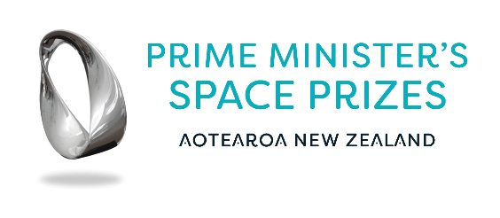

**Prime Minister’s Space Prize for Professional Excellence**

**Application form**

**(Please keep written material to three pages)**

Adjudication for the prize will be decided by the Ministry based on the recommendations of selected panel members.

Recommendations will consider applicants based on the extent to which a significant impact, contribution, and/or transformative achievement in the space sector *and/or* emerging aviation sector has led to significant economic, health, social and/or environmental impact on or for New Zealand, or internationally. This can be evidenced in a variety of ways, for example:

* *Successful development and deployment in the space sector and/or emerging aviation sector of new or improved products, processes, or services (including public services) based on research.*
* *Major changes to practice in the space sector and/or emerging aviation sector, at a national level.*
* *Significantly increased investment in the space sector and/or emerging aviation sector over an extended period of time by potential or actual technology transfer partners or end users.*
* *Significant changes in the way a body of knowledge relevant to the space sector and/or emerging aviation sector, is organised and used (as a result of challenging previous conventional wisdom).*
* *Development of new methods that have advanced research practice in the space sector and/or emerging aviation sector.*
* *Inspired the next generation into the space sector and/or emerging aviation sector.*

(start writing here)

**Evidence Portfolio**

You may use the next 10 pages for your evidence portfolio.